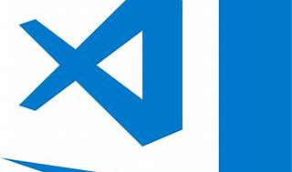

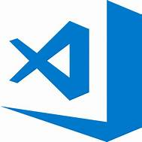

Explore

**Visual Studio Code (VS Code)** is a **lightweight yet powerful source code editor** that runs on Windows, macOS, and Linux. [It’s designed for building and debugging modern web and cloud applications, and it supports various programming languages and extensions1](https://code.visualstudio.com/)[2](https://visualstudio.microsoft.com/)[3](https://www.infoworld.com/article/3666488/what-is-visual-studio-code-microsofts-extensible-code-editor.html).

Here are **five free resources** where you can learn more about Visual Studio Code:

1. [**Get Started with Visual Studio Code**](https://code.visualstudio.com/learn/): This official guide provides introductory videos and coding packs for Java and .NET, helping you kickstart your coding journey with VS Code[4](https://code.visualstudio.com/learn/).
2. [**Learn .NET**](https://dotnet.microsoft.com/en-us/learn): Explore free tutorials, videos, and courses to learn C# and other .NET technologies using Visual Studio Code[5](https://dotnet.microsoft.com/en-us/learn).
3. [**.NET for Students**](https://dotnet.microsoft.com/en-us/learntocode): Specifically tailored for students, this resource offers essential tools to start building apps with C# and F# using the .NET Coding Pack for VS Code[6](https://dotnet.microsoft.com/en-us/learntocode).
4. [**Introduction to Visual Studio Code**](https://learn.microsoft.com/en-us/training/modules/introduction-to-visual-studio-code/): Learn how to assess whether VS Code is the right editor for your development needs, covering web, C++, and data science scenarios[7](https://learn.microsoft.com/en-us/training/modules/introduction-to-visual-studio-code/).
5. [**Learn to program with Visual Studio Code**](https://code.visualstudio.com/learntocode): Dive into tutorials, explore VS Code extensions, and discover features like source control, custom themes, and Jupyter Notebooks integration[8](https://code.visualstudio.com/learntocode).

Happy coding! 🚀